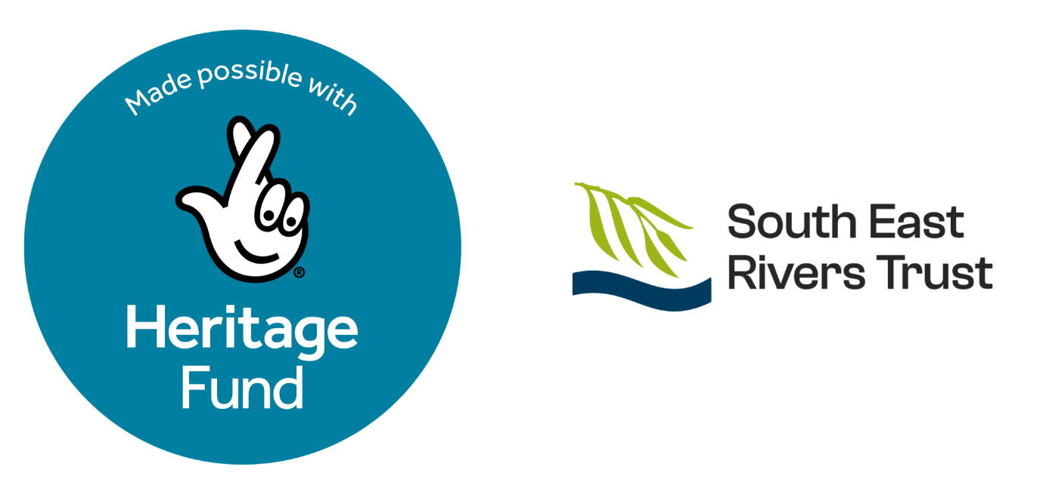

South East Rivers Trust
Micro Grant Application Form

© 2026 The South East Rivers Trust
Registered charity number: 1091000. Registered office: 1st Floor, Arthur Stanley House, 40-50 Tottenham Street, London, W1T 4RN. Registered in England & Wales as a company limited by guarantee. Company registration number: 03969688
Connect House, Kingston Road, Leatherhead, KT22 7LT, 0845 092 0110

Section 1 - About You

Please complete the shaded boxes. Check the applicable boxes and provide concise details. If a section does not apply, write "N/A".
Provide details for the person who is responsible for this application form and answering any questions that we may have about your project.
If you’re applying as an organisation, you must provide your organisation’s registered office address. If you are applying as a non-constituted group, then this must be the address of the lead applicant.
If you are an informal or non-constituted group that does not currently have a name, work together to come up with something that best describes you as a group.

- Organisation/Group Name
- Organisation/Group Address
- Organisation/Group Email Address
- Organisation/Group Phone Number
- Main Contact Full Name
- Main Contact Email Address
- Main Contact Phone Number
- Please select one option which best fits your group | - Educational Establishment  - Registered Charity  - Informal or non-constituted group  - Community Interest Company (CIC_  - Social Enterprise  - Constituted Community Organisation  - Friends of Group  - Tenants and Residents Association  - Faith Group  - Youth Group  - Other (Please state below)
- If you’re a registered charity, what is your charity registration number?
- Do you have an organisation/group bank account? (Yes/No)

- Tell us about your group/organisation. (250 words)
Give us an overview of the aims of your group/organisation. What services do you provide and who do they aim to support (e.g. certain demographics, identities or communities) (include one example of past projects if relevant).

- Is your group/organisation equity-led? Tell us about your answer (100 words)
By equity-led we mean that your group/organisation is run by and for the communities you aim to support (i.e. your staff, senior management and trustees identify as these communities).

- Do you have a website or any social media channels that you can share with us?
Facebook, X, Instagram etc

- Summarise your project idea in 15 words or fewer.
E.g. “Pilot bat walk project for elderly people on the Wandle”

- Which river catchment do you intend to deliver this project? (Please select one)
We plan to offer one grant per river catchment.
- Wandle
- Hogsmill
- Darent
- Cray

- What do you propose to do (Include information on how and whom you will get involved from a community perspective).
(250 words)
Provide a clear description of what you are requesting funding for. Tell us the key information about your project:
- Who it will support and why (i.e. target demographics)
- What activities you are planning?
- If this is a pilot project, what are your plans for the future?
- If this is a continuation, what have you learnt from previous delivery?

- How does your proposal link to the Chalk Streams Connector Project. (250 words)
The purpose of this grant is to help organisations to continue delivering, or start to deliver, local focused projects that aim to prevent/respond to river accessibility inequalities around the Hogsmill & Beverley Brook, Darent, Cray, and the Wandle, by funding small scale community engagement activities. Applicants will be required to evidence how their proposal will promote river accessibility for underrepresented communities, namely people from minoritised ethnic backgrounds, people with disabilities, impairments and/or mental health conditions, young people (aged 16-30) and older people (65+).

- How will you measure success and what would success look like? (250 words)

- When do you plan to complete your project by?
This can be approximate, but please note that project must be delivered by October 31st, 2026.

- When will you deliver key project activities?
If possible, please let us know the approximate dates for when key activities and tasks will take place. We would like to have a member of SERT staff attend key activities; this will be communicated to you beforehand.

- Risks - Tell us about the three main risks to your project and how you plan to reduce the chances of them affecting your project’s success.
Risk | Mitigation / Controls | Notes

- Permissions and Insurance (Do you need any special permissions, and do you hold the necessary insurance policy withing your organization to deliver this project?) If you are not sure, please contact us.

- Safeguarding Requirements
Is safeguarding required for this project? | ☐ Yes ☐ No
If yes, what are the safeguarding measures that you have in place (e.g., DBS checks, supervision, policies)

If no, why not?

Section 3 - Budget

- Funding Summary – How do you intend to spend your grant?
Make sure you breakdown how you have calculated costs e.g. staff costs – workshop facilitator for 2 sessions at £100 per session, £200.
Please refer to the microgrant description document on what we can and can’t fund.

Simple Budget (you can add/adjust rows as needed)
Item / Description | Cost (£) | Notes
Total Amount Requested (£)

- Where did you hear about this grant application?

By submitting and signing this application, you confirm the information provided is accurate to the best of your knowledge.

Signature: ……….................................. Date: ………...….

