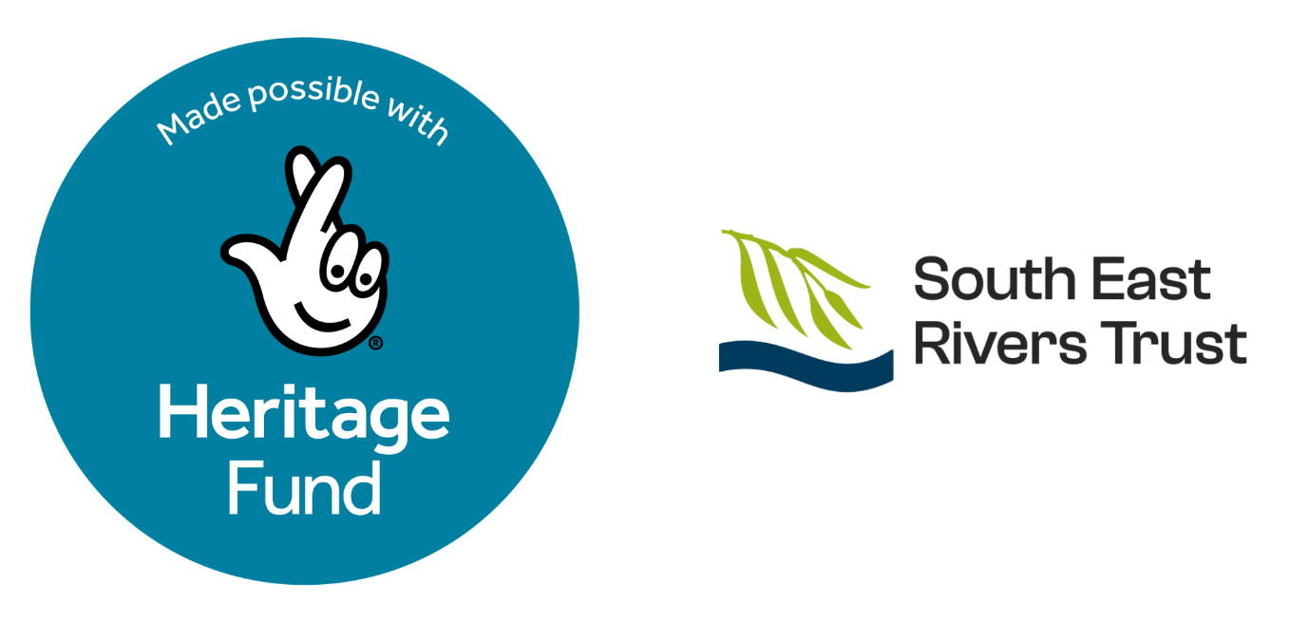

Chalk Streams Connectors: Microgrants
Purpose
The South East Rivers Trust (SERT) has received development funding from the National Lottery Heritage Fund to deliver the Chalk Streams Connectors project on the Hogsmill, Cray, Darent, and Wandle. We’re supporting local initiatives that improve accessibility to these streams, with a focus on underrepresented communities, through inclusive, community-led activities.
Aims of the grant
The purpose of this grant is to help organisations to continue delivering, or start to deliver, local focused projects that aim to prevent/respond to river accessibility inequalities around the Hogsmill, Cray, Darent, and the Wandle, by funding small scale community engagement activities. This may be pilot projects or the continuous development of small existing projects. We are particularly interested in receiving applications that demonstrate innovation and learning from previous delivery. Applicants will be required to evidence how their proposal will promote river accessibility for underrepresented communities, namely people from minoritised ethnic backgrounds, carers (young and adults), people with disabilities, impairments and/or mental health conditions, young people (aged 16-30) and older people (65+). Examples include litter picks, nature connection workshops, storytelling workshops, outdoor skills workshops to increase confidence with the outdoors, bird watching activities etc.
Who can apply?
Eligible groups should be based and operate in the catchment areas of the Hogsmill, Cray, Darent, and the Wandle. You can use this tool to look at the geographical area of the streams. The following groups* are eligible for the microgrant funding: Community groups, charities, educational establishments, youth groups, faith groups, “Friends of” groups and community interest companies.
You are not eligible if you are: a private company, a political group, a statutory body, companies limited by shares, Local Authorities, GP practices and NHS Trusts, or organizations controlled by any of those organizations.
If you are not sure about your eligibility, please contact us.
*You will be asked to provide your governing document. If you don’t have a governing document, please get in touch with us.
What we fund
Examples of eligible costs include venue hire, workshop materials, translation/interpretation, volunteer expenses*, etc.
* Volunteer expenses should only cover subsistence including travel costs to and from the project delivery location.
The events should:
- Be free to attend and openly accessible to the general public and/or outlined underrepresented groups.
- Be inclusive, accessible and attractive to a diverse, new or broad range of audiences.
- Encourage people to spend more time in nature.
- Take place by 31/10/26.
- Demonstrate a commitment to environmental sustainability and how this project will benefit Nature as well as people.
- Contribute to the well-being of local communities.
- Engage with safeguarding and safety guidelines You can find an example here.
Examples of non-eligible costs include
- Salaries
- Pensions
- Insurance
- Capital costs, etc.
If you are not sure about eligible costs, please contact us.
Grant size
- Up to £800 per group.
- Additional funding may be requested in special circumstances (e.g., communication costs, BSL interpreter).
- We expect to fund up to 7 grants.
- No match funding required.
Timeline & how to apply
- Project delivery window: June–October 2026
- Application deadline: 17 April 2026
- Decisions communicated: By end of April 2026
- Payment: Details will be shared with successful applicants.
- You can download the application form through our website. If you have trouble accessing the application form, please email us at kostas.stavrianakis@southeastriverstrust.org and we’ll share it with you.
- Email your completed application form to kostas.stavrianakis@southeastriverstrust.org
Support from SERT
- Lending equipment (e.g., litter‑picking gear, tea urns, ID guides) Feel free to reach out to us for any equipment you need that SERT might be able to provide you with.
- Advising on risk assessments
- Support to complete the funding application. Grassroots/un-constituted groups can have a call with us to discuss their application but that it is dependent on staff capacity.
- Advertising your activities through SERT channels
- Sharing information about your chosen river
Reporting & dissemination
- Please provide a brief report with photographs after the project has ended, highlighting outcomes and gaps addressed. You can also submit a video explaining the aims of the project and what you achieved through the microgrant. Please contact us to share the post-project development template with you. We need to receive this report by 30/11/26.
- Participate in a knowledge sharing event hosted by SERT in January 2027 to celebrate and showcase the work done by the recipients of the microgrants.
- As this project is funded by the Heritage Fund, acknowledgement should be made to the Heritage Fund for supporting and funding those grants. We will provide you with the necessary toolkit.
Assessment criteria
Alignment with the Chalk Streams Connectors project.
We aim to support one project per stream.
Community benefits & outreach
Inclusion & accessibility
Feasibility within the timeframe
Value for money
Future opportunities (e.g., sustainability, legacy)

Questions? Email kostas.stavrianakis@southeastriverstrust.org

